Title
QoE-Aware JSON Variance Analytics System for Streaming API Validation

Field of the Invention
The present disclosure relates generally to validation of application programming interfaces (APIs), and more particularly to systems and methods for validating JSON-based streaming service APIs using data analytics that correlate JSON payload variance with quality-of-experience (QoE) metrics in a media streaming environment.

Background
Modern media streaming platforms employ microservice architectures with numerous JSON-based APIs providing functionality such as catalog discovery, personalized recommendations, playback initiation, entitlement checks, subtitle delivery, and ad decisioning. Each microservice may be independently deployed and versioned, causing frequent changes in response schemas and values.
Conventional API testing and contract-testing frameworks typically treat JSON responses as static contracts. Consumer-driven contract testing frameworks (e.g., Pact-like systems) and snapshot-based tests validate whether an API response matches an expected schema and values, often stored as static fixtures or schemas. If any deviation is detected, the test fails, regardless of whether the deviation has any impact on actual user-perceived QoE.
At the same time, streaming platforms continuously measure QoE and service-level metrics such as startup latency, buffering ratio, stall events, average bitrate, playback error rate, session completion rate, and recommendation click-through rate. These metrics are generally analyzed independently of API contract testing—typically at the player/network layer or via QoE analytics engines focused on media delivery, not JSON payload semantics
Consequently:
- Many benign JSON changes (e.g., re-ordered recommendation lists or non-critical field changes) cause noisy test failures and high maintenance overhead for test fixtures.
- Conversely, some JSON changes that appear small (e.g., entitlement flags, region rights, ad configuration) can cause significant QoE degradation but may not be captured as critical regressions by purely structural contract tests.
- Existing API validation approaches do not systematically combine JSON variance with QoE or KPI analytics to decide whether a deviation should be accepted, warned, or treated as a regression.
There is a need for a system that:
- Compares JSON-to-JSON across mocks and live responses.
- Understands schema evolution over time.
- Uses data analytics and QoE metrics to distinguish harmless variance from harmful regressions.
- Automatically maintains an inventory of expected responses and schema mappings for streaming APIs.

Summary
In one aspect, a computer-implemented system validates JSON-based API responses in a streaming media platform by combining JSON variance analytics with QoE telemetry.
The system maintains:
- A scenario repository storing baseline JSON request and response pairs for streaming API endpoints.
- A schema inventory that captures one or more JSON schemas for each endpoint and mappings between different schema versions.
- A QoE metrics store containing per-session QoE and KPI metrics such as startup delay, buffering ratio, playback failure rate, completion rate, and recommendation click-through rate.
For a candidate deployment or configuration change of a microservice, the system:
- Obtains a candidate JSON response for a test JSON request corresponding to a scenario.
- Aligns the candidate JSON response with an expected JSON response using the schema inventory and stored mappings when schemas differ.
- Computes JSON variance features representing structural and value differences between candidate and expected responses.
- Applies a data-analytics model trained on historical JSON variance features and associated QoE metrics to compute an anomaly score or multi-dimensional variance tensor that estimates the QoE risk of the variance.
- Classifies the candidate response as an accepted variance or regression based at least in part on the anomaly score.
- Automatically updates the schema inventory and/or baseline response when variances are repeatedly classified as accepted, while flagging regressions for investigation.
In some embodiments, the data-analytics model incorporates semantic embeddings of JSON fields, temporal drift detection over rolling windows of responses, field-level criticality weights learned from correlations between field changes and QoE degradation, and multi-region consensus analysis.
In other aspects, systems and non-transitory computer-readable media implement the methods described herein.
This approach enables streaming platforms to:
- Reduce false positive test failures due to harmless response changes.
- Quickly detect and prioritize regressions that materially impact QoE.
- Automatically evolve API baselines and mocks as services change, while remaining aligned to user experience.

Brief Description of the Drawings
The accompanying drawings, which are incorporated in and constitute a part of this specification, illustrate exemplary embodiments.
- FIG. 1 is a block diagram of an example streaming API validation system.
- FIG. 2 is a logical diagram of the scenario repository and schema inventory.
- FIG. 3 is a flowchart of an example training workflow for the variance analytics model.
- FIG. 4 is a flowchart of an example validation workflow for candidate API deployments.
- FIG. 5 illustrates an example JSON variance feature vector for aligned responses.
- FIG. 6 illustrates an example QoE-aware variance decision timeline across deployments.
- FIG. 7 illustrates a user interface for displaying field-level variance and QoE impact.

Detailed Description of Example Embodiments

1. System Overview (FIG. 1)
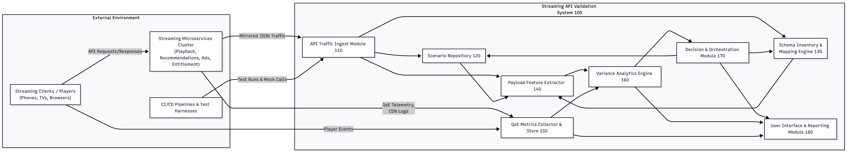
Referring to FIG. 1, an example Streaming API Validation System 100 includes:
- API Traffic Ingest Module 110
- Scenario Repository 120
- Schema Inventory and Mapping Engine 130
- Payload Feature Extractor 140
- QoE Metrics Collector and Store 150
- Variance Analytics Engine 160
- Decision and Orchestration Module 170
- User Interface and Reporting Module 180
The system 100 may be implemented using one or more servers, virtual machines, or cloud instances connected via a network to streaming service microservices and client devices.
1.1 API Traffic Ingest Module 110
The API Traffic Ingest Module 110:
- Obtains JSON-based API request and response pairs from:
  - Test harnesses or CI/CD pipelines.
  - Mirrored production traffic (e.g., via service mesh or API gateway).
- Associates each pair with metadata:
  - Endpoint identifier (e.g., /play, /recommend, /entitlement).
  - Microservice version or build identifier.
  - Region, device type, client application version.
  - Session or correlation ID and timestamp.

1.2 Scenario Repository 120
The Scenario Repository 120 stores test scenarios:
- Each scenario includes:
  - A baseline request JSON payload (e.g., tests/xxx.json).
  - A corresponding expected response JSON payload (e.g., responses/xxx.json).
  - An endpoint identifier, scenario label (e.g., “cold start play,” “returning user recommendation”), and optional tags (e.g., “4K HDR,” “ad-supported”).
Scenarios may originate from:
- Manually authored tests.
- Automatically harvested examples from production that are later curated and promoted to baselines.
- Synthetic cases derived from specifications or OpenAPI/Swagger documents.

1.3 Schema Inventory and Mapping Engine 130 (FIG. 2)
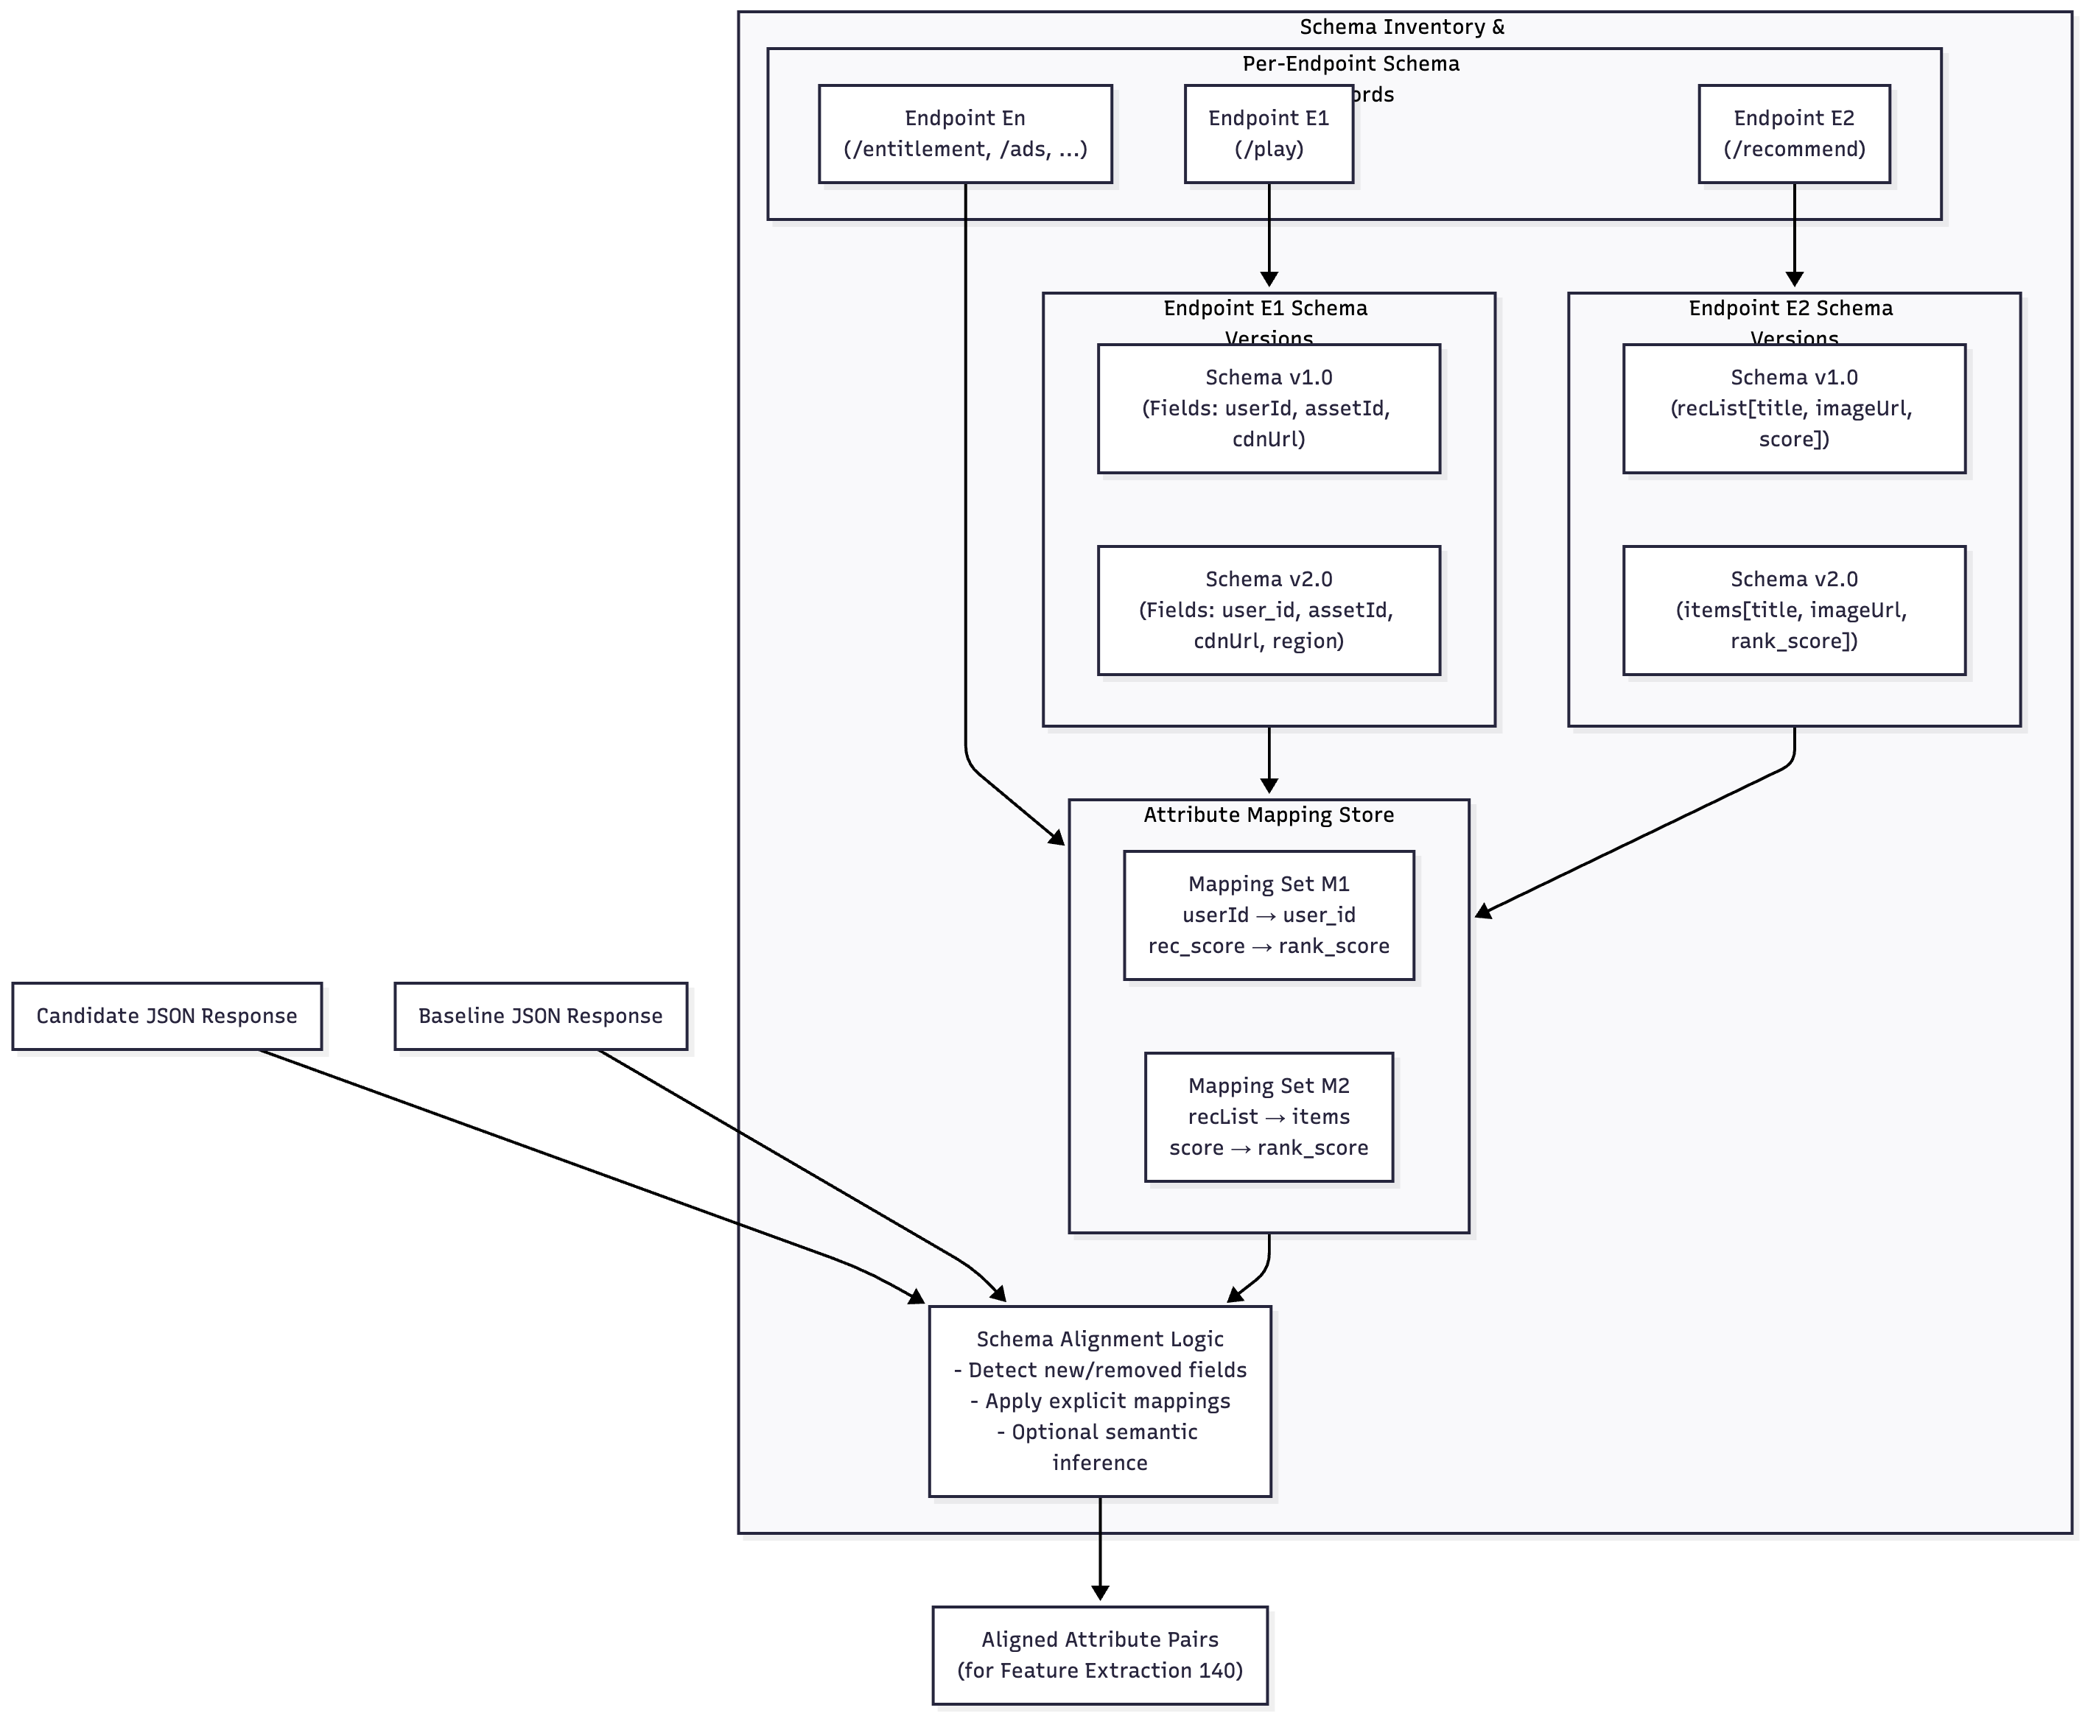
The Schema Inventory 130 maintains:
- For each endpoint:
  - One or more JSON schemas representing observed response structures, including field names, data types, nesting, and cardinalities.
  - A set of schema versions, each identified by a version ID or hash.
  - A set of attribute mappings between schema versions, e.g., mapping userId in version v1 to user_id in version v2.
The Mapping Engine:
- Detects when new responses introduce previously unseen fields or remove existing ones.
- Aligns attributes between a candidate response and a baseline response by:
  - Applying explicit mappings from the inventory; and/or
  - Inferring mappings from semantic similarity of field names or values (e.g., via embeddings) as described below.
This component enables the system to handle schema evolution without immediately failing all tests.

1.4 Payload Feature Extractor 140 (FIG. 5)
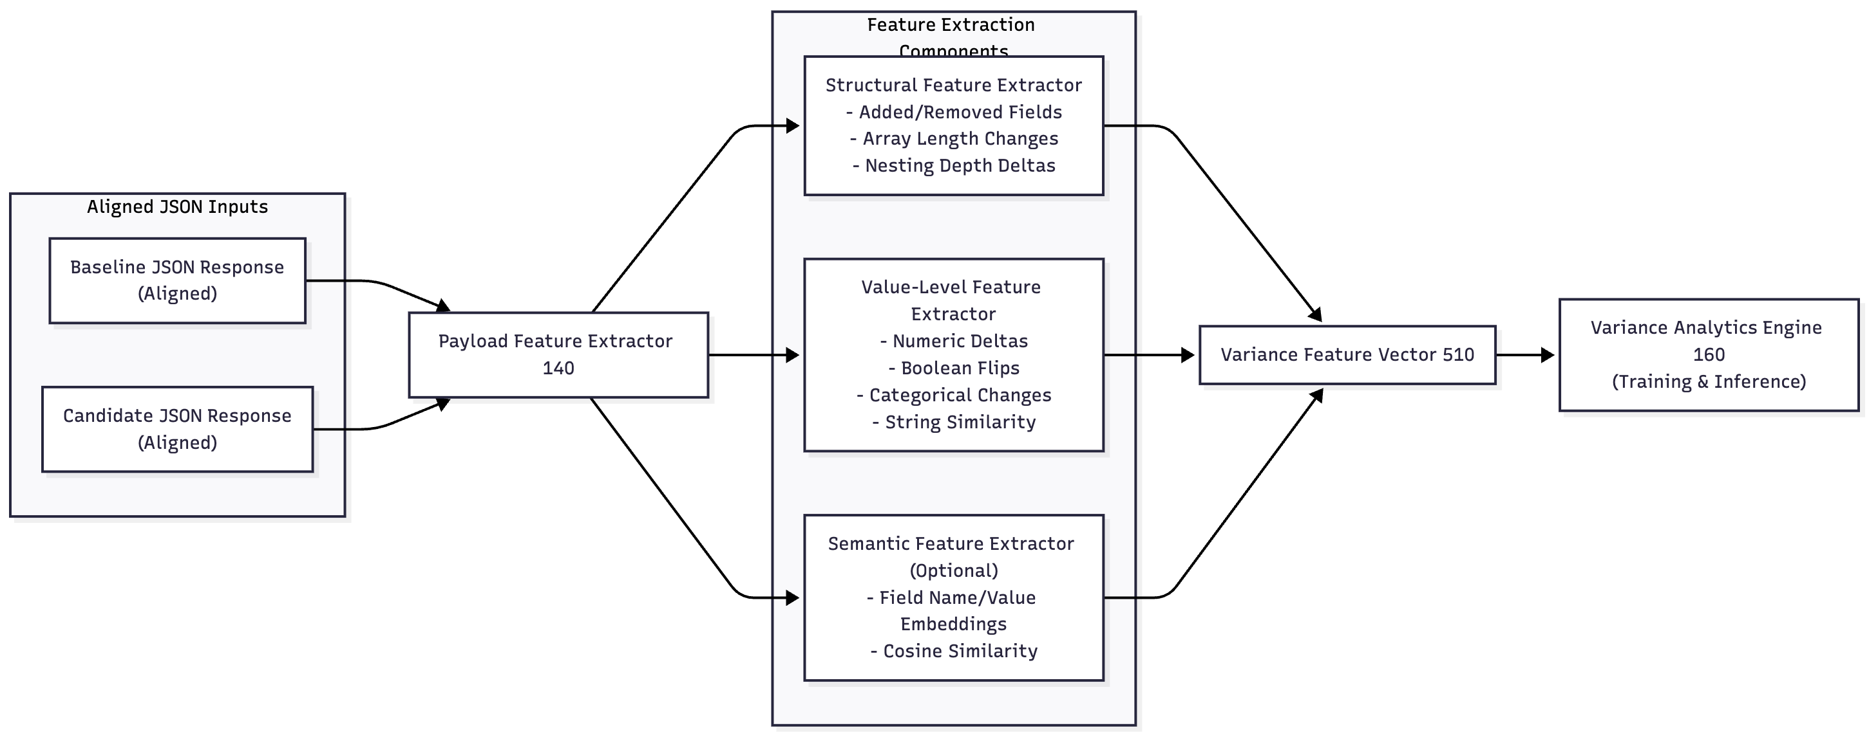
Given a pair of JSON responses (baseline and candidate) that have been schema-aligned, the Payload Feature Extractor 140 computes a variance feature vector including:
- Structural features:
  - Count of added attributes.
  - Count of removed attributes.
  - Depth differences for specific fields.
  - Changes in array lengths (e.g., number of recommended items).
- Value-level features:
  - Numeric deltas (e.g., change in recommendation_score or bitrate).
  - Boolean flips (e.g., is_entitled from true to false).
  - Categorical changes (e.g., region = US → EU).
  - String similarity measures for text fields (e.g., content titles).
- Semantic features (optional):
  - Embedding vectors for field names and/or values, obtained from a text encoder (e.g., domain-fine-tuned transformer).
  - Cosine similarity between baseline and candidate embeddings for selected fields.
The extractor can be configured to ignore unstable or index-like fields (e.g., timestamps, session IDs) or to treat them with low importance.

1.5 QoE Metrics Collector and Store 150
The QoE Metrics Collector 150:
- Receives streaming QoE and KPI metrics from player analytics, CDN logs, and monitoring systems, such as:
  - Video startup delay.
  - Rebuffering frequency and duration.
  - Average or effective bitrate.
  - Playback error rate and error codes.
  - Session completion ratio.
  - Recommendation click-through rate (CTR).
  - Ad impression vs ad-start/completion rates.
- Associates QoE metrics with API responses by:
  - Correlation IDs propagated through request–response chains.
  - Time window matching between API calls and subsequent playback events.
  - Device ID / user ID / session ID matching.
The QoE Metrics Store maintains historical QoE data keyed by endpoint, scenario, region, and time.

1.6 Variance Analytics Engine 160
The Variance Analytics Engine 160 is the core analytics component. It:
- Builds training examples from historical data:
  - For each endpoint and scenario, pairs:
    - Variance features between a baseline response and a candidate response.
    - Associated QoE metrics observed after the candidate response was used in production (or in a staging environment).
- Labels or characterizes examples as:
  - QoE-neutral or QoE-improving.
  - QoE-degrading or anomalous.
  - Ambiguous/unknown (for semi-supervised or unsupervised approaches).
- Trains one or more models, for example:
  - A supervised classifier that outputs a probability of QoE degradation given the variance feature vector.
  - A regression model predicting expected change in one or more QoE metrics resulting from the JSON variance.
  - An unsupervised drift detector that flags unusual variance patterns even without explicit labels.
- Produces an anomaly or variance score, e.g.:
  - A scalar anomaly score in [0, 1].
  - A vector or tensor including:
    - Structural anomaly measure.
    - Value-level anomaly measure.
    - QoE-risk measure.
    - Regional inconsistency measure.
The engine may incorporate:
- Feature weighting schemes where each JSON attribute has a criticality score derived from observed correlation between changes in that attribute and QoE changes.
- Temporal models that consider variance patterns across multiple deployments or time windows.
- Multi-region consensus, where responses are compared across data centers or CDNs and anomalies specific to a region are distinguished from global anomalies.

1.7 Decision and Orchestration Module 170 (FIG. 4 & FIG. 6)
FIG. 4
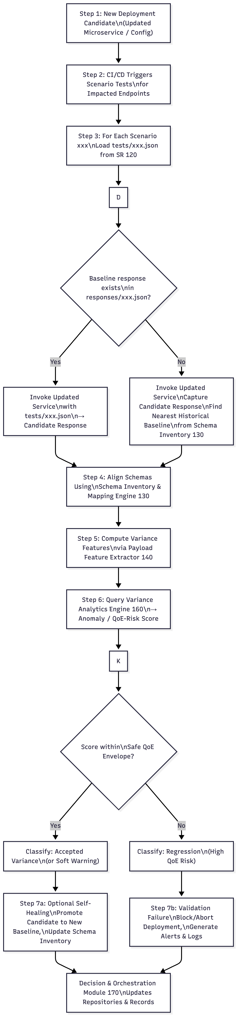
FIG. 6
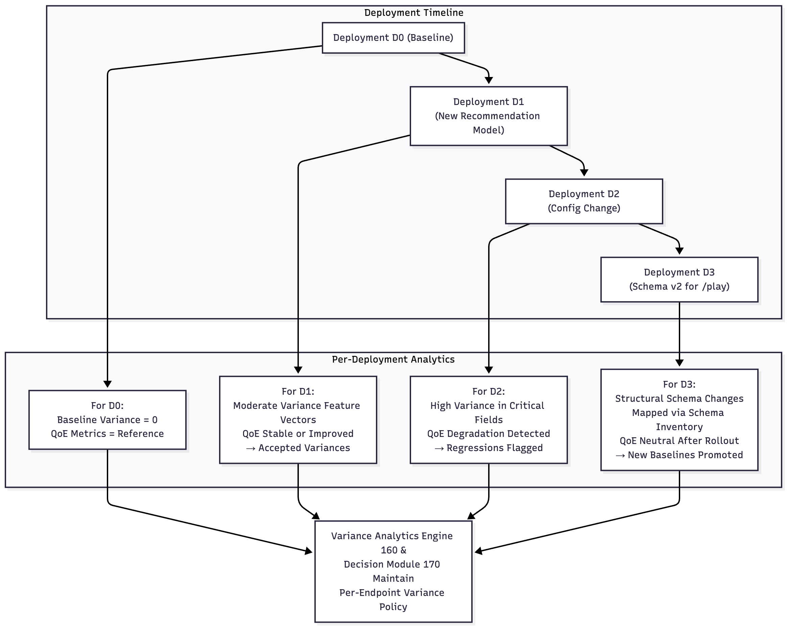
The Decision Module 170 orchestrates validation workflows and acts on the analytics output.
For a given candidate deployment of one or more microservices, and for each scenario:
- Scenario selection:
  - Identify relevant test scenarios in the Scenario Repository 120 for the impacted endpoints.
- Response acquisition:
  - If a baseline response exists for the scenario:
    - Generate a candidate response by invoking the updated microservice using the baseline request payload.
  - If no baseline response exists:
    - Invoke the updated microservice and capture the candidate response, optionally comparing to the nearest historical response from the Schema Inventory 130.
- Variance analysis:
  - Use the Schema Inventory 130 to align schemas.
  - Compute variance features via Payload Feature Extractor 140.
  - Query Variance Analytics Engine 160 to obtain an anomaly or variance score.
- Classification and action:
Based on thresholds and policies, classify each candidate response into categories such as:
  - Accepted variance: Within learned safe envelope; no expected QoE impact.
  - Soft warning: Detectable change with low but non-zero QoE risk; may require review.
  - Regression: High QoE risk or structural break; deployment should be blocked or rolled back.
- Self-healing baseline management:
  - For accepted variances that remain QoE-neutral across multiple deployments, automatically:
    - Promote the candidate response to become the new baseline JSON response.
    - Update the schema inventory to include new attributes and mappings.
  - For regressions:
    - Add examples to the training dataset as negative samples.
    - Generate alerts and reports to engineering teams.
This module may be integrated into CI/CD pipelines so that any change to an endpoint triggers the above process during build or deploy.

1.8 User Interface and Reporting Module 180 (FIG. 7)
The UI 180 provides:
- A per-endpoint view showing:
  - Recent candidate responses and their classification.
  - Field-level contributions to the anomaly score (e.g., via SHAP-like explanations).
  - QoE trendlines before and after deployments.
- A per-scenario view showing:
  - Baseline JSON response.
  - Candidate JSON response.
  - Highlighted differences (added/removed/changed fields) with QoE-weighted coloring.
- Controls for:
  - Manually overriding classification decisions.
  - Confirming promotion of candidate responses to new baselines.
  - Adjusting thresholds or policies for specific endpoints (e.g., stricter for entitlement APIs).
This UI can form the basis of a design patent or utility continuation claim around visualization and operator workflows.

2. Example Workflows

2.1 Training Phase (FIG. 3)
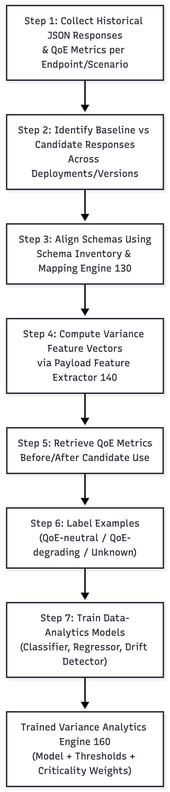
- Collect historical JSON responses and QoE metrics for an endpoint (e.g., /recommendations).
- Identify baseline responses and subsequent candidate responses across versions.
- Align schemas and compute variance features between baseline and candidate.
- Retrieve QoE metrics before and after the change for sessions impacted by the candidate responses.
- Label examples as QoE-neutral or QoE-degrading based on QoE thresholds.
- Train a classifier to map variance features to QoE-risk scores.
- Repeat per endpoint and scenario; optionally train a shared or multi-task model across endpoints.

2.2 Validation Phase During Deployment (FIG. 4)

- A new recommendation engine is rolled out.
- CI pipeline triggers scenario-based tests for /recommendations.
- For each test scenario xxx:
  - Call updated service with tests/xxx.json.
  - Retrieve candidate response.
  - Align with baseline responses/xxx.json.
  - Compute variance features and anomaly score.
- Classify as accepted variance or regression.
- Block deployment if one or more scenarios are classified as regression above a policy threshold.
- If accepted and later confirmed QoE-neutral in production, promote candidate responses to new baselines.

3. Implementation Variations
The system may be implemented in various ways, including but not limited to:
- Different model families for the Variance Analytics Engine (e.g., gradient-boosted trees, neural networks, probabilistic models).
- Use of embedding and graph-based representations of JSON (e.g., graph neural networks for schema evolution) as described in the specification but left to narrower claims.
- Different strategies for capturing live traffic (e.g., mirroring, shadowing, canary deployments).
- Application to various streaming-related APIs beyond video (e.g., audio streaming, game streaming, or other real-time services).

Claim Set

Independent Claim 1 – Method
- A computer-implemented method for validating JSON-based application programming interface (API) responses in a streaming media platform, the method comprising:
(a) storing, in a scenario repository, a plurality of baseline JSON request payloads and corresponding baseline JSON response payloads for a plurality of streaming API endpoints;
(b) maintaining, in a schema inventory, for each of the streaming API endpoints, at least one JSON schema describing a structure of the baseline JSON response payloads and at least one mapping between attributes of different versions of the JSON schema;
(c) collecting, from a telemetry system of the streaming media platform, quality-of-experience (QoE) metrics associated with client sessions that invoke the streaming API endpoints, the QoE metrics comprising at least one of startup delay, buffering ratio, playback error rate, completion rate, and recommendation click-through rate;
(d) training, using one or more processors, a data-analytics model by:
(i) generating, from historical JSON response payloads and the baseline JSON response payloads, a plurality of variance feature vectors, each variance feature vector describing structural and value differences between a pair of JSON response payloads; and
(ii) correlating the variance feature vectors with corresponding QoE metrics to learn a relationship between JSON response variance and QoE impact;
(e) for a candidate deployment of a microservice implementing a given streaming API endpoint:
(i) obtaining, by invoking the given streaming API endpoint with a selected baseline JSON request payload, a candidate JSON response payload;
(ii) determining, using the schema inventory, whether a schema of the candidate JSON response payload matches a schema of a baseline JSON response payload associated with the selected baseline JSON request payload, and when the schema differs, applying the mapping to align at least a subset of attributes between the candidate JSON response payload and the baseline JSON response payload;
(iii) computing, from the aligned attributes, a current variance feature vector describing structural and value differences between the candidate JSON response payload and the baseline JSON response payload; and
(iv) applying the trained data-analytics model to the current variance feature vector to generate an anomaly score indicative of a likelihood that the differences will degrade QoE;
(f) classifying the candidate JSON response payload as one of an accepted variance or a regression based at least in part on the anomaly score; and
(g) when the candidate JSON response payload is classified as an accepted variance, updating at least one of the schema inventory or the baseline JSON response payload to incorporate the candidate JSON response payload as a revised baseline, and when the candidate JSON response payload is classified as a regression, generating a validation failure notification for the given streaming API endpoint.

Independent Claim 2 – System
- A system for validating JSON-based application programming interface (API) responses in a streaming media platform, comprising:
  - one or more processors; and
  - a non-transitory computer-readable storage medium storing instructions that, when executed by the one or more processors, cause the system to perform operations comprising the steps of the method of claim 1.

Dependent Claims
- The method of claim 1, wherein computing the variance feature vectors comprises computing structural variance features including at least one of: a count of added attributes, a count of removed attributes, and a change in array length for a list of recommended items.
- The method of claim 1, wherein computing the variance feature vectors comprises computing value variance features including at least one of: a numerical difference for a numeric field, a categorical change for an enumerated field, and a boolean flip for a boolean field.
- The method of claim 1, wherein computing the variance feature vectors further comprises computing semantic similarity features by generating embedding vectors for at least one of JSON field names or JSON field values and computing a similarity measure between embedding vectors of the baseline JSON response payload and the candidate JSON response payload.
- The method of claim 1, wherein the data-analytics model is configured to assign a criticality weight to each JSON attribute based on an observed correlation between changes in the JSON attribute and changes in the QoE metrics, and wherein the anomaly score is a function of both the variance feature vector and the criticality weights.
- The method of claim 1, wherein training the data-analytics model comprises labeling training instances as QoE-neutral or QoE-degrading based on whether the QoE metrics satisfy a predefined performance threshold.
- The method of claim 1, wherein the streaming API endpoints comprise at least two of: a playback initiation endpoint, a content recommendation endpoint, a subtitle endpoint, and an ad decision endpoint.
- The method of claim 1, wherein the operations further comprise:
  - obtaining, from a plurality of geographic regions, JSON response payloads for a same scenario;
  - computing variance feature vectors between the JSON response payloads across the plurality of regions; and
  - distinguishing local anomalies that affect a subset of the plurality of geographic regions from global anomalies that affect all of the plurality of geographic regions.
- The method of claim 1, wherein updating the baseline JSON response payload comprises writing the candidate JSON response payload to the scenario repository as a new baseline only after a plurality of candidate deployments produce anomaly scores that satisfy an acceptance threshold and corresponding QoE metrics that satisfy a QoE stability condition.
- The method of claim 1, further comprising generating, via a user interface, an explanation for the anomaly score that identifies one or more JSON attributes whose changes contribute above a contribution threshold to classification of the candidate JSON response payload as the regression.
- The method of claim 1, wherein the schema inventory is further configured to infer mappings between attributes of different schema versions based on semantic similarity of attribute names or values.
- The method of claim 1, further comprising:
- when no baseline JSON response payload exists for the selected baseline JSON request payload, selecting a historical JSON response payload having a closest matching schema from the schema inventory as a provisional baseline; and
- computing a variance feature vector between the candidate JSON response payload and the provisional baseline for use by the data-analytics model.
- The method of claim 1, wherein the operations are performed responsive to a proposed deployment of a new version of a microservice and prior to activating the proposed deployment in a production environment.
- The method of claim 1, wherein the QoE metrics further comprise at least one of: an ad impression-to-completion ratio and a recommendation click-through rate, and wherein the anomaly score is endpoint-specific.
- The method of claim 1, further comprising:
- receiving, from an operator via the user interface, a manual override that confirms acceptance of a candidate JSON response payload; and
- incorporating the candidate JSON response payload and associated QoE metrics into a training dataset for retraining the data-analytics model.
- The system of claim 2, wherein the instructions further cause the system to:
- expose an application programming interface for external test orchestration services to request validation of JSON responses; and
- return a structured validation result comprising at least the anomaly score, the classification, and a field-level variance summary.
- The system of claim 2, wherein the user interface is configured to display a timeline of anomaly scores for a given streaming API endpoint across multiple deployments together with corresponding QoE metric trends.
- The method of claim 1, wherein training the data-analytics model further comprises applying a drift detection algorithm over sequences of variance feature vectors to identify temporal drifts that correlate with QoE degradation.
- The method of claim 1, wherein classifying the candidate JSON response payload as one of the accepted variance or the regression further comprises assigning the candidate JSON response payload to one of a plurality of validation states comprising at least: pass, soft warning, and fail, based on the anomaly score and at least one policy parameter associated with the given streaming API endpoint.

